Qigong, Creativity and the Three Treasures

A camp with time for connection to the Earth, and love and respect for all life. A camp for self-development, enjoyment and a deep experience of Nature

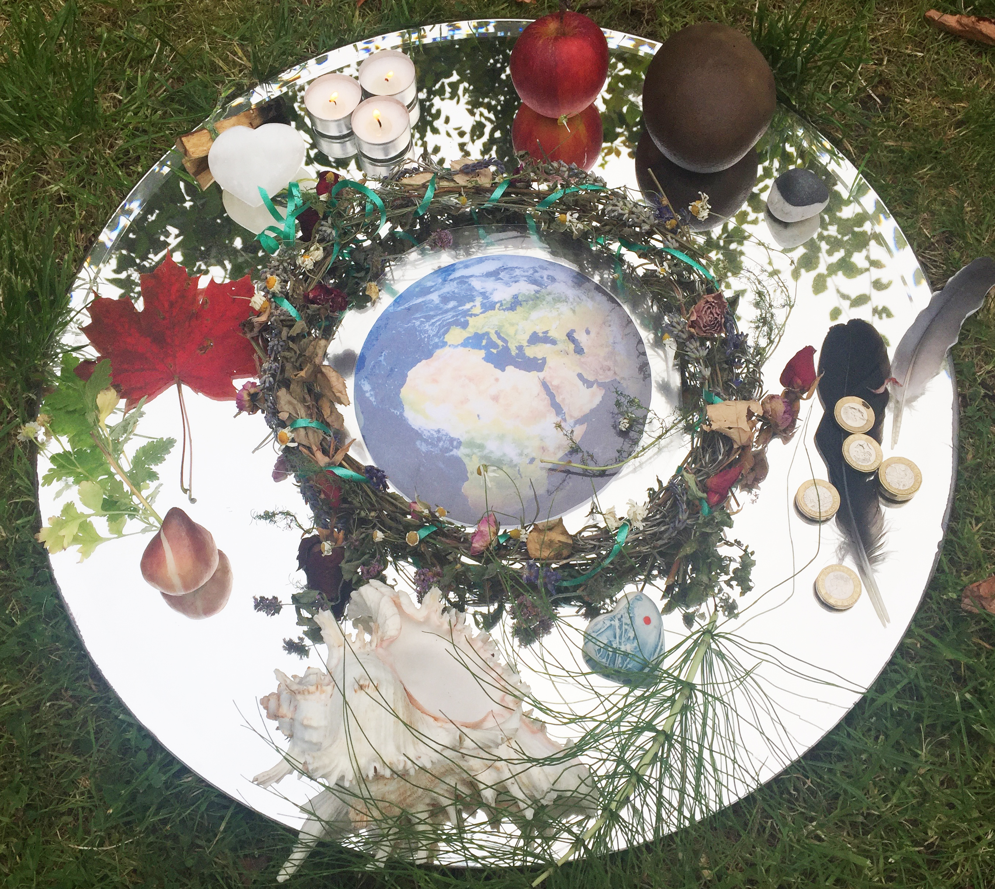

Thursday 8th - Monday 13th June 2023
May Hill Woodlands

Nicola, Sarah and Helen
Are pleased to have booked exclusive use of the lovely Mayhill campsite. We have developed a programme based on the three treasures – Jing, Qi and Shen - which will deepen our connection to Nature using Qigong and creativity.

“This has been a truly wonderful experience. The inspiration, healing and awakening have been everything I needed and so much more. Thank-you” Chris - Three Treasures Camp 2021

The Programme
Each day we will explore one of the three treasures. We will use Qigong forms, meditation, creativity, and ceremony to enhance our own Jing – physical body, Qi –our life force, and Shen our spirit. Qigong practice supports our health at all levels and awakens our joy in life.

- Before Breakfast - Qigong 7.30 – 8.45
- Breakfast
- Qigong session - 10.15 – 11.30
Tea break
Meditation, discussion or a quiet time with Nature.
Lunch break.
- Creative play – (Roughly 3.00 – 5.00pm)
- A time for an evening meal.
- The evening - Will be a more informal space for sharing what has arisen in the day. A poem, a picture, a song or a dream! A fire or a cosy, early night.

The Qigong
Our practice comes from a variety of traditions and requires no previous experience of any sort, only a willingness to explore your own energy.

Everyone is welcome; no experience of Qigong or Creativity is needed. We hope you will bring an intention to connect to yourself and our community and the Earth with love and respect.

The Site
The camp is situated in the ancient woodland around May Hill in the Forest of Dean. It is a 20 minute drive from Gloucester which has good road and rail links. We have exclusive use of a large barn, with a cooker, compost toilets, showers and a lovely camping field and a secluded space for camper vans. There is running water, a fire pit with benches and plenty of wood, but not electricity.
Bring a tent or a camper van and cooking equipment and plenty of warm things. Some folks have even booked a B and B near by.

The Food
There will be a welcoming soup available on the first day. Otherwise we are not providing meals and suggest people cook in small circles of no more than 6, friendship or family groups and bring exactly what nourishes you.

The cost:
is £210 for the camp, all the workshops and art materials.

There are 35 places available
A small deposit of £50 will secure your place. Email Sarahmacdonald43@gmail.com to book your place and for bank details.

Covid -19
We will keep an eye on the legal requirements.
Currently we would like everyone to do a test before you arrive so we all feel safe.

Your hosts are:
Nicola Ley

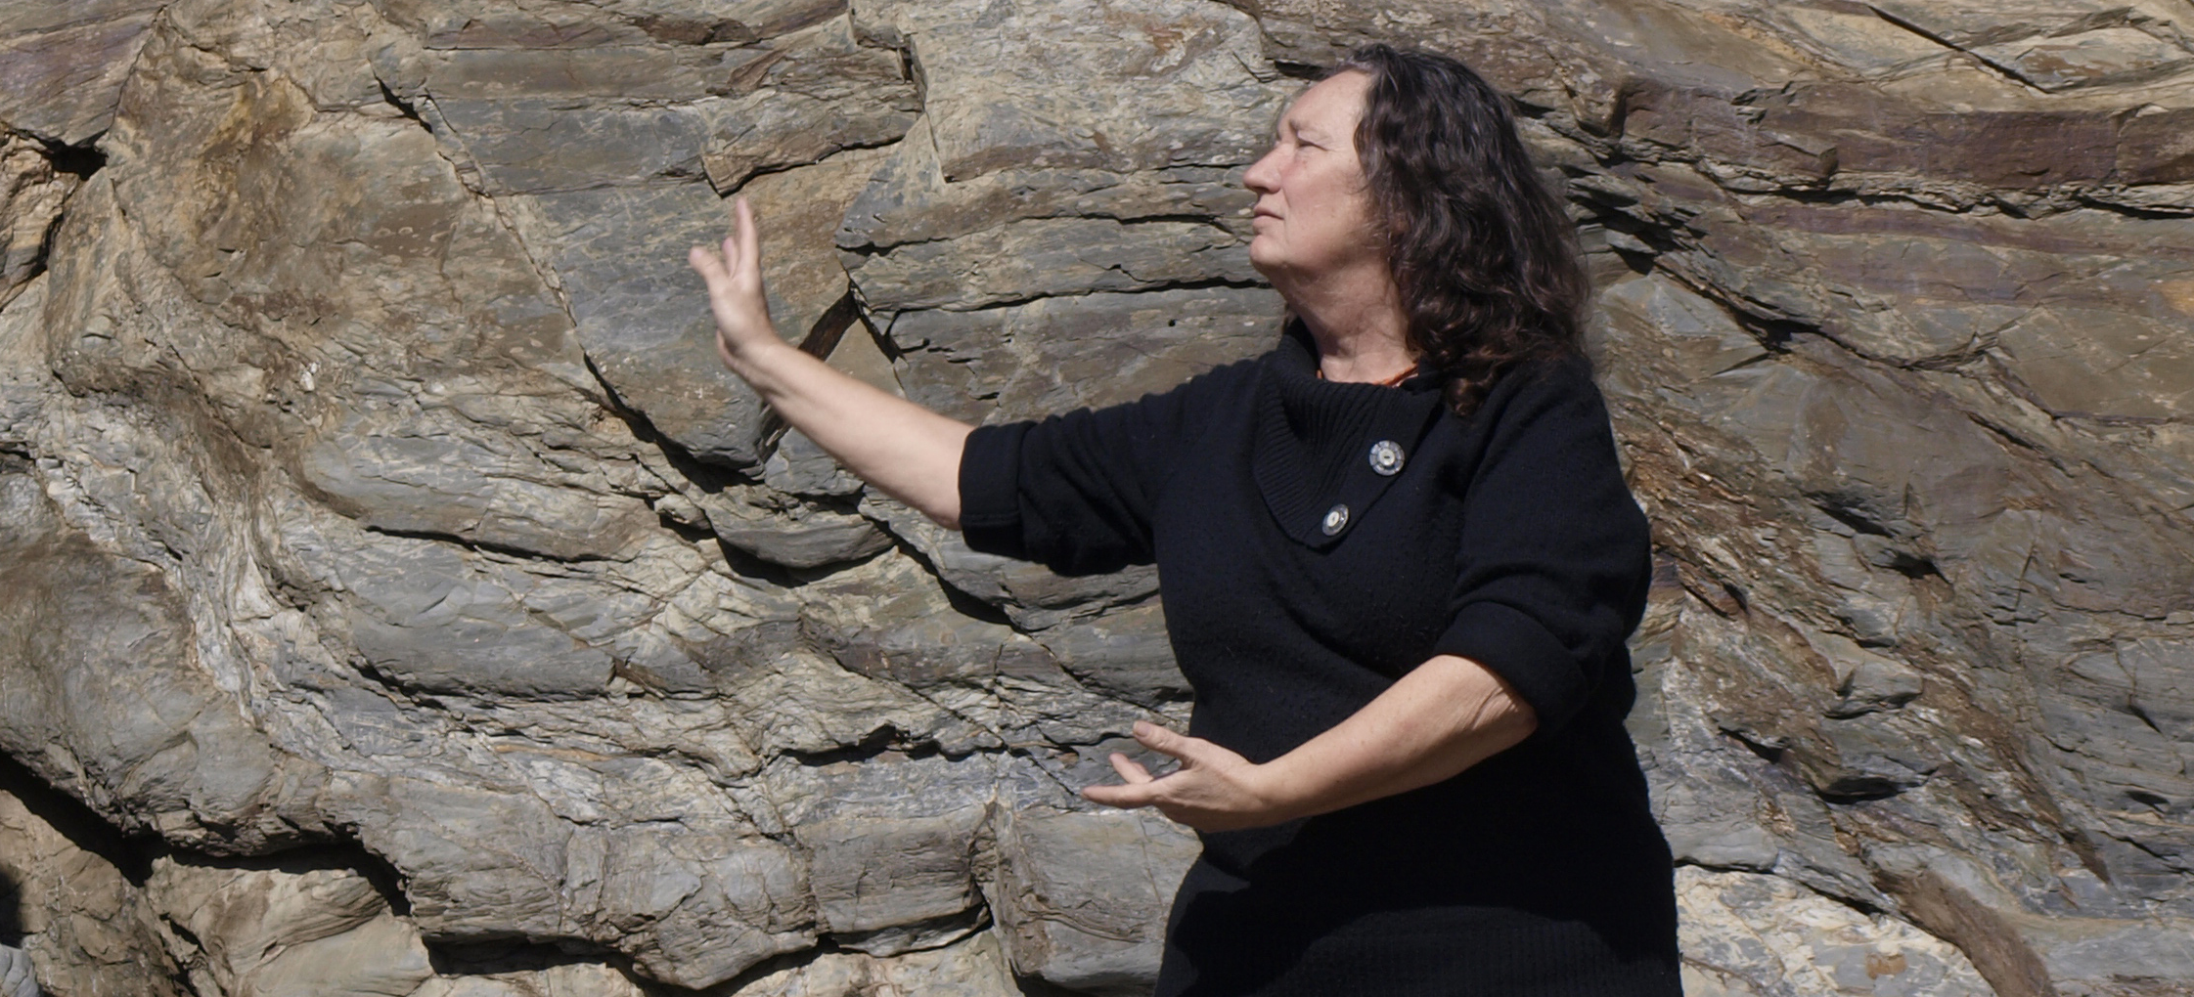

Nicola loves to teach Qigong. She really enjoys being in Nature so to offer Qigong and an experience of the five elements for a select group is her idea of heaven. Read more about her at qigong-bristol.co.uk

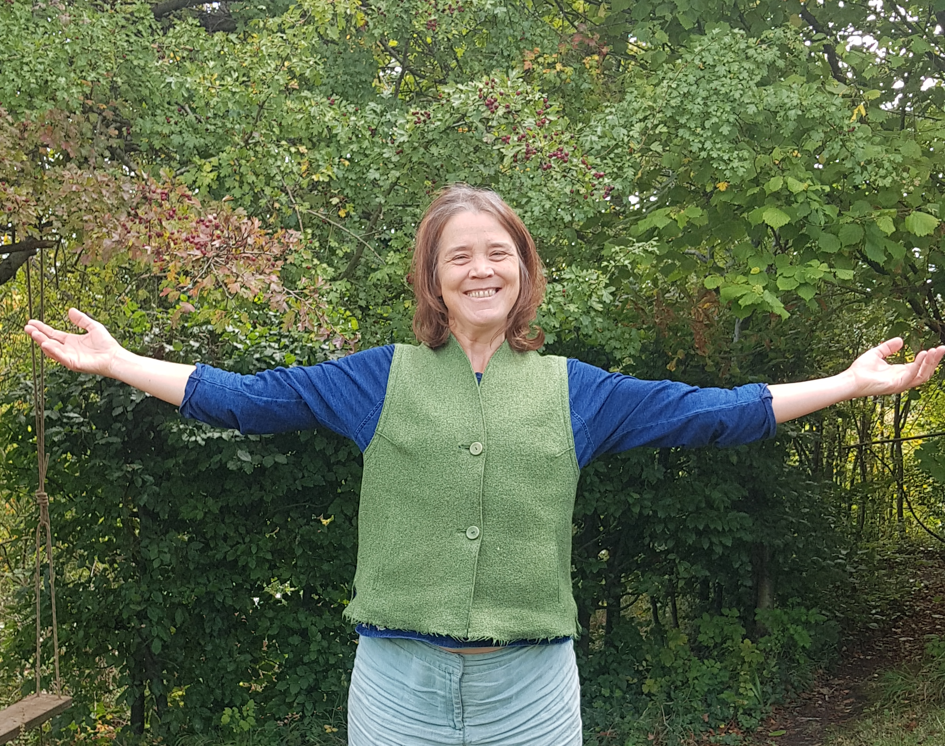

Sarah MacDonald
Sarah teaches exquisite qigong and loves nothing better than camping in the rain. As a One Spirit Interfaith Minister she has a passion for supporting spiritual health and will bring a fresh take to your practice and your meditation. https://exploringspirit.co.uk

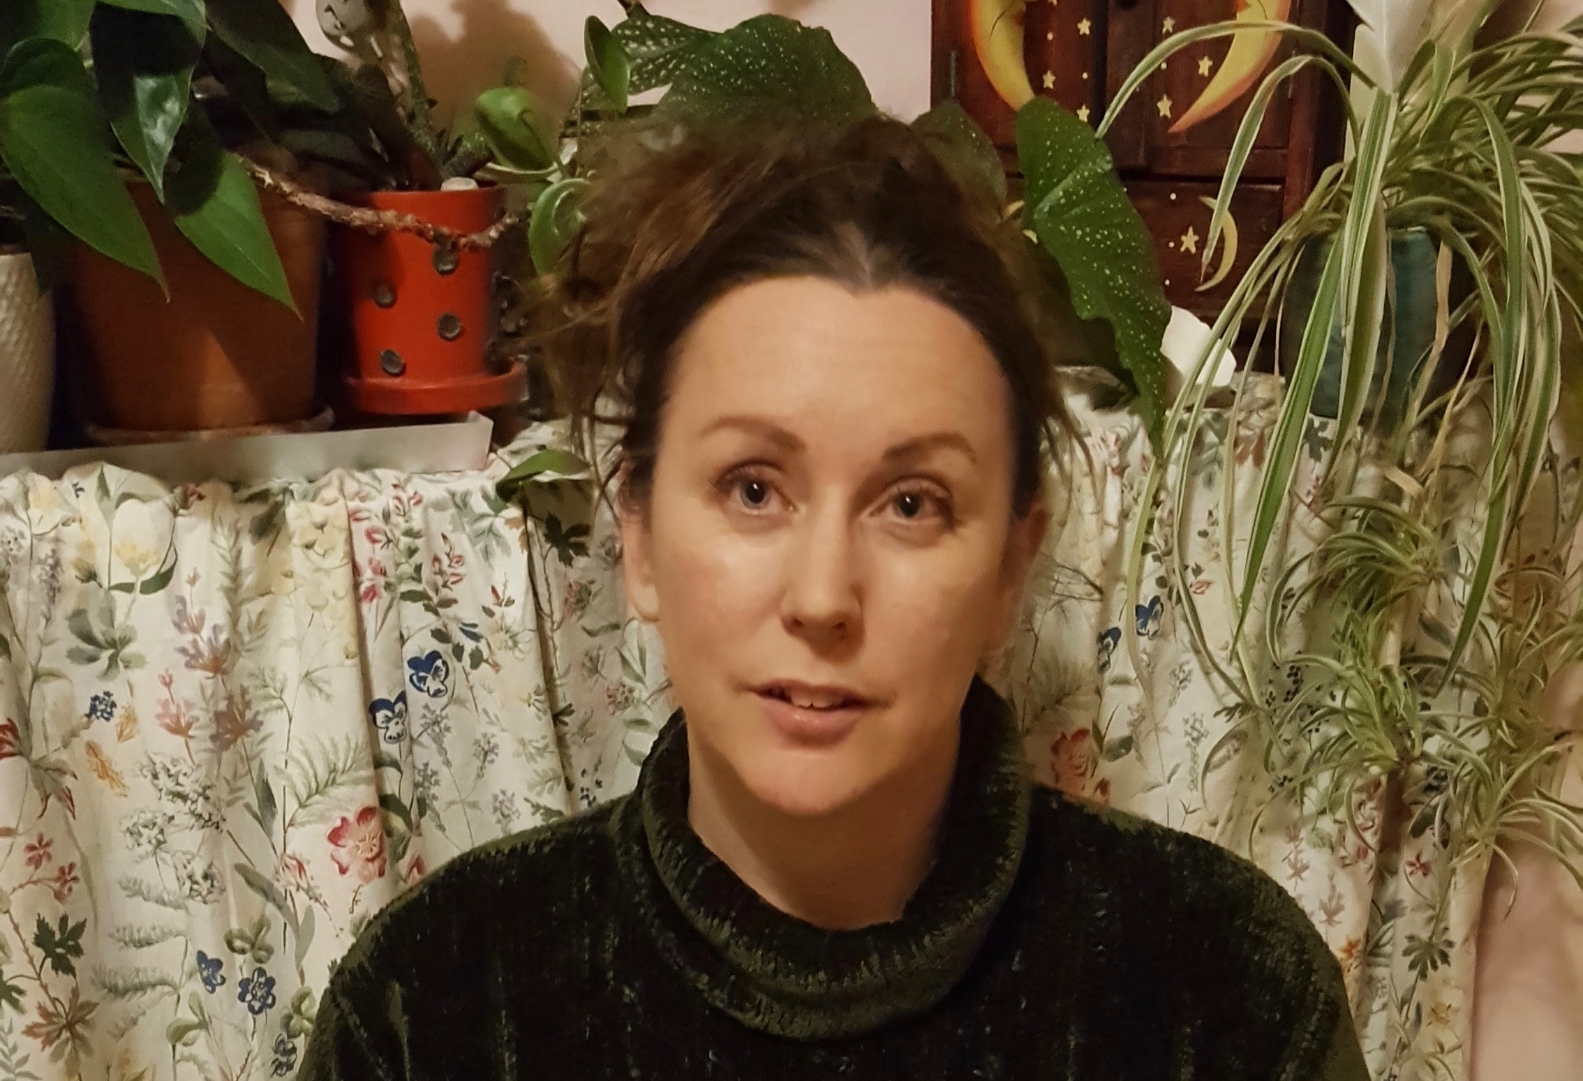

Helen Lawrence:
Helen is an artist who loves working with groups in nature to help free creative expression, making art with natural materials, clay and paint.

Find out more about the site here:
https://www.mayhillwoodlands.com

